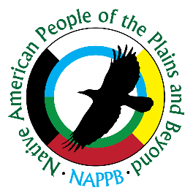**Native American People of the Plains and Beyond**

**501c3 Charity Native American Organization**

**Membership Application**

Welcome to Native American People of the Plains and Beyond.

Your decision to become a member entitles you to have an equal say in matters concerning the Organization. NAPPB is funded solely by its members, sponsors, fund raisers, donations, and grants.

|  |  |
| --- | --- |
| First Name: ______________________________ | Last Name: ______________________________ |
| Address: ________________________________ | City, State, Zip: ___________________________ |
| Phone: __________________________________ | Email: ___________________________________ |
| Birthday: _______________________________ | Anniversary: _____________________________ |

|  |  |
| --- | --- |
| First Name: ______________________________ | Last Name: ______________________________ |
| Address: ________________________________ | City, State, Zip: ___________________________ |
| Phone: __________________________________ | Email: ___________________________________ |
| Birthday: _______________________________ | Anniversary: _____________________________ |

|  |  |
| --- | --- |
| Child Name: _____________________________ | Birthday: ________________________________ |
| Child Name: _____________________________ | Birthday: ________________________________ |
| Child Name: _____________________________ | Birthday: ________________________________ |
| Child Name: _____________________________ | Birthday: ________________________________ |

Member Ship Dues:

Individual Membership: $25.00 per year

College Student Membership: $15.00 per year (18-25)

Family Membership: $ 40.00 Per Year (All-inclusive up to 18 years of age)

Military & First Responders: Past and Present $10.00 per year; Family $20.00 Per Year (up to 18 years of age).

Amount Enclosed:

Check $ ___________________ Check Number: _________________ PayPal: __________________

**If paying by PayPal, we still need your application to be sent to the address below.**

**Please make checks payable to NAPPB and mail your application and membership fee to:**

**Native American People of the Plains and Beyond**

**9823 County Road 5400**

**Shallowater, Texas 79363 Cell: 254-855-3937**